Dhvanil Shah

Professor Hakner

ECE-357

01 October 2018

Problem Set 2 – Question 3

**My Find (no arguments)**

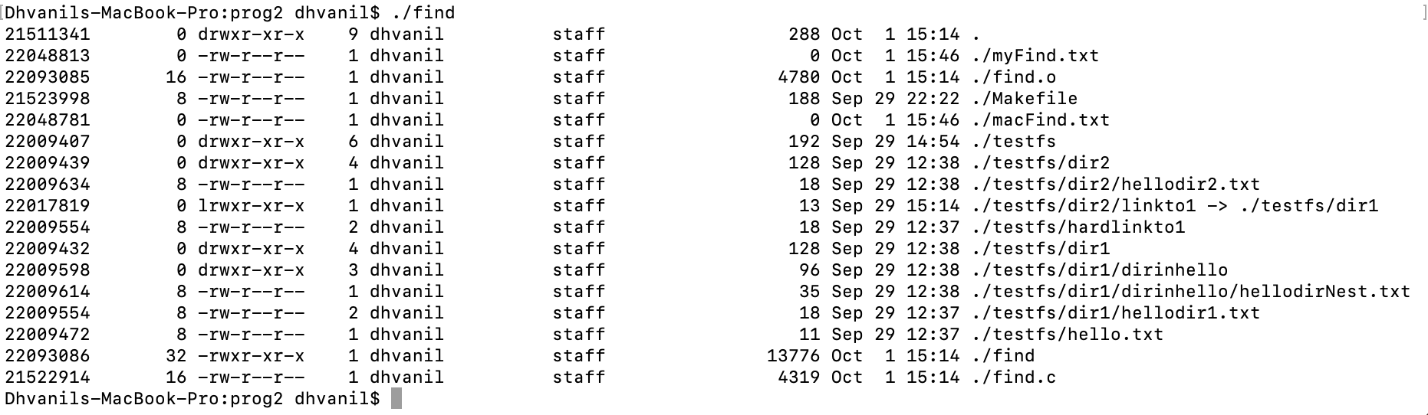

**My Find (directory as argument)**

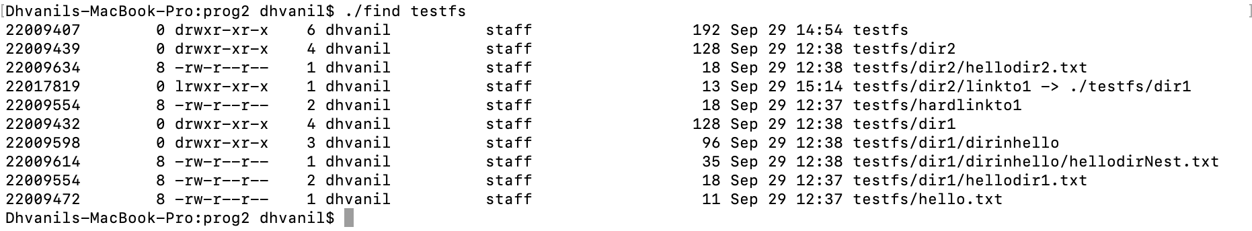

**My Find Error Catching**



**My Find Compared with “find” Command (with and without “diff”)**

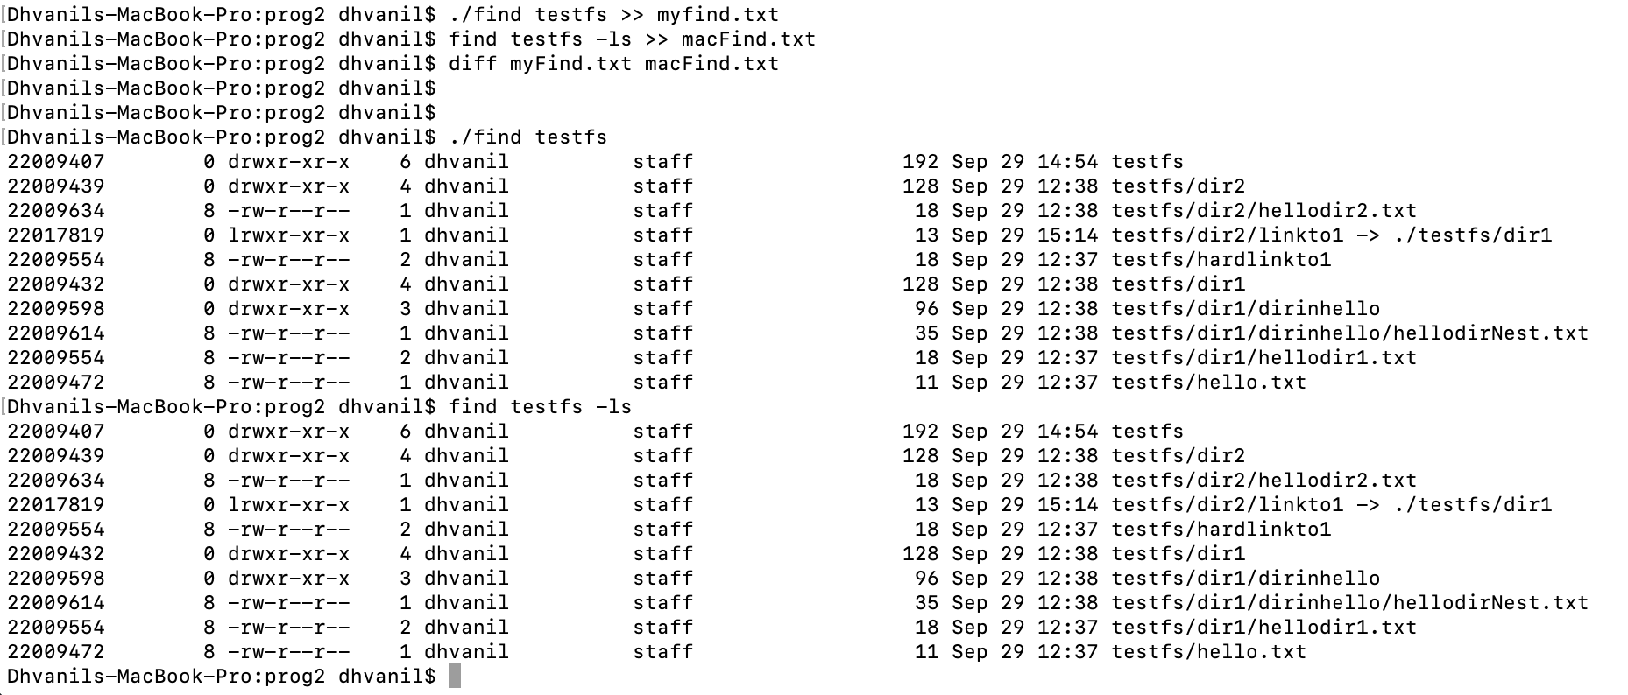

*symbolic link used is sufficient for demonstration purposes but is an invalid link because it links a file to a directory